** *Douglas Park Community Elementary***

***5409-206 Street, Langley, BC, V31 2C5***

**Phone: 604-533-4491 Fax: 604-533-7803**

**Principal: Mrs.D. Wilk Email:** [dwilk@sd35.bc.ca](mailto:dwilk@sd35.bc.ca)

**Vice Principal: Mr. R. Dorland Email:** [**rdorland@sd35.bc.ca**](mailto:rdorland@sd35.bc.ca)

**Admin Assistant: Kim Langford Email:** [klangford@sd35.bc.ca](mailto:klangford@sd35.bc.ca)

**­­­­­­­­­­­­­­­____________________________________________________________________________________**

October 26th, 2018

Dear Douglas Park Families,

With another month come and gone we have a lot to be thankful and excited for. Here is a look back at a wonderful October and a look ahead to what is shaping up to be a memorable November.

**A Look Back**

**Emergency Ready**- Students and staff alike did their part in making sure our school is safe in case of emergencies. Students were educated about what to do in case of a fire when we celebrated fire safety week. All in all, students and staff partook in two fire drills, a lockdown drill and an earthquake drill. Staff also completed Epipen training.

**Student Vote**- Just like many of you did on the 20th our students participated in a vote. Grade 4/5 students demonstrated leadership running the entire stuent vote election.

**Picture Day**- October 1st was our school picture day. If you need a retake, then mark November 7th on your calendar.

**D.E.A.R. Week**- Drop Everything and Read week just concluded. Students could be found reading in every nook and cranny of our school. Mrs. Wilk also got in the action, and could regularly be found reading in a classroom. Just for fun, ask your child what the name of the tree is!

**Crazy Hair Day**- Besides all the help from you in styling up your child’s hair to celebrate school spirit, another big thank you goes out to students from Aldergrove Secondary School who turned our school into a hair salon for those kids who were unable to have their hair styled at home.

**Student-Led Conferences and Parent Teacher Interviews**- Thank you to all the families that came out. Remember that teachers are more than happy to open classroom doors to talk about your child upon request.

**Douglas Soccer**- Thanks to coaches Mr. Solano and Ms. Langford, soccer has invaded Douglas Park. It is wonderful seeing the teamwork that is being exhibited on our soccer field on Wednesdays.

**Lights**- If you haven’t already witnessed, please come into our school and look up at our lights. Thank you to the students at Walnut Grove Secondary School for making our new beautiful light covers.

**A Look Ahead**

**Collaboration Afternoon**- We have two scheduled. Monday, October 29th and November 20th. Dismissal at 1:15pm.

**Halloween**- On Wednesday, October 31 students are invited to wear their Halloween costumes for the day. After recess we will have a costume parade through the classrooms and meet in the gym for The Monster Mash. Please ensure that your child dresses appropriately - costumes are all about having fun, not violence or gore. Alternate activities will be available for students who are not comfortable with the parade.

Costume Rules:

·         Costumes need to be age appropriate

·         Costume choices should allow students to still go about their daily activities.

·         No weapons (even toy) of any description

·         No masks

·         No blood

**Photo Retakes**- November 7th

**Remembrance Day Assembly**- Join us on November 8th at 1pm. School will be closed November 12th.

**Report Card Prep- Half Day**- November 26th

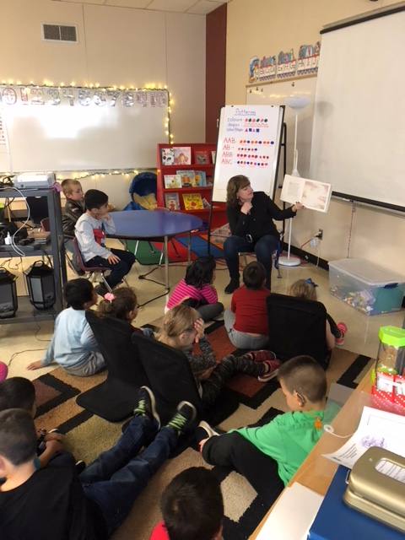. 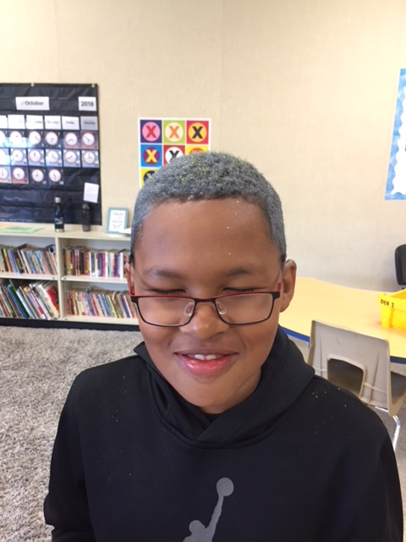 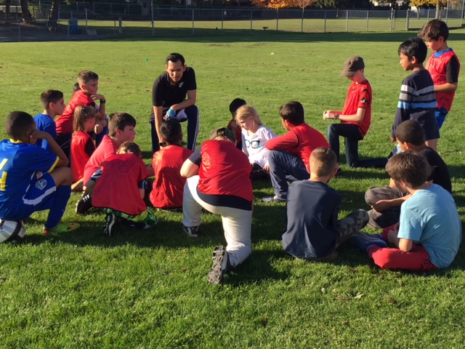

Mr. Ron Dorland

Vice Principal- Douglas Park Community School