** *Douglas Park Community Elementary***

***5409-206 Street, Langley, BC, V3A 2C5***

**@DPCEDragons**

**Phone: 604-533-4491 Fax: 604-533-7803**

**Principal: Mrs.D. Wilk Email:** [dwilk@sd35.bc.ca](mailto:dwilk@sd35.bc.ca)

**Vice Principal: Mr. R. Dorland Email:** [rdorland@sd35.bc.ca](mailto:rdorland@sd35.bc.ca)

**Admin Assistant: Kim Langford Email:** [klangford@sd35.bc.ca](mailto:klangford@sd35.bc.ca)

**­­­­­­­­­­­­­­­____________________________________________________________________________________**

**January Newsletter**

Dear Families,

We hope you had an amazing winter break. It was wonderful having so many families join us for our pizza lunch on December 28th. Since returning, students have settled back into their classroom routines. New soccer nets have been installed, which in turn has caused many students to walk onto the pitch and run around. Inside the walls you can hear songs echo through the hallways as we are getting ready for our kindness assembly.

Kindergarten registration is currently open. Please register at the school. If you have questions regarding registering your son/daughter at Douglas Park for next year, please call our school at (604) 533-4491.

**Upcoming Events**

Basketball Home Games- Jan 29, Feb. 19

1:15pm Early Dismissal - Feb. 6

Lions Pancake Breakfast- Feb. 14

Professional Day- Feb. 15

Family Day- Feb. 18

Report Card Prep Half Day- Feb. 25

Kindness and Inclusion Concert- Feb. 26

Pink Shirt Day- Feb 27

**In the Community**

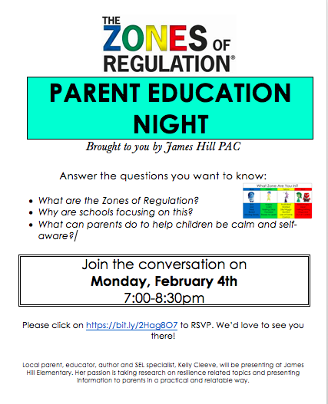 

Ron Dorland

Vice Principal, Douglas Park Community School