November Newsletter

Dear Douglas Park Families,

Don’t look now but the winter break is less than a month away. But before we look ahead to a short December, let’s take a moment to look back at what was a wonderful month of learning.

With the winter weather upon us please remember to dress you child appropriately. If possible please have a change of clothes at school. As the weather gets colder it may be wise to start your walk to sc

A Look Back

Remembrance Day- Our Remembrance Day assembly highlighted showed respect and thanks to those individuals who helped and continue to help make our country a wonderful place to live. Thank you to Austin, Ms. Heidi and a group of students for creating this powerful banner for our assembly.

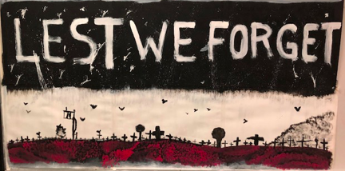

Craft Fair- Last Saturday staff and students were standing behind tables and selling items that our students worked so hard on. From ornaments and decorations to school calendars, homes in our community will be festive and full of the love and spirit of our school. Thank you to our PAC, our staff, students and all the parents for making this event happen!

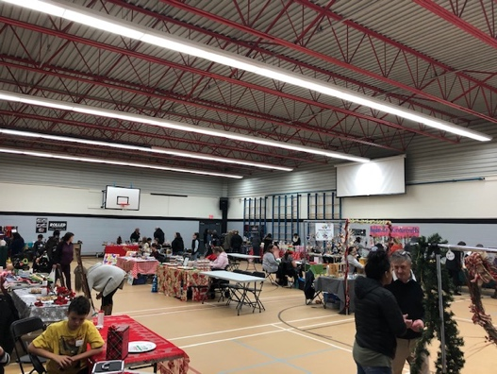

A Big Thank You!- Thank you to the Nicomekl PAC who purchased brand new school uniforms for our school. What a gift it was to receive brand new jerseys, matching our new school look. They look amazing!
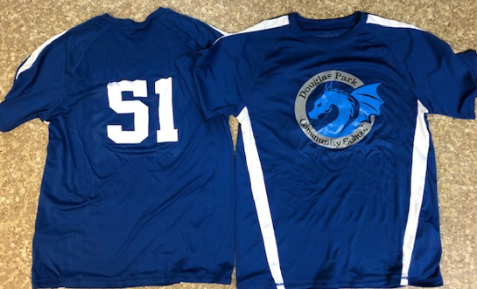

Meet a New Member to Our School- This cute and soft friend that one of our students is holding is Douglas “Dougie” the Dragon. Douglas is given out to the class that best demonstrates safe and respectful behaviour in our assemblies. Our November winner was Mrs. Kara’s class!

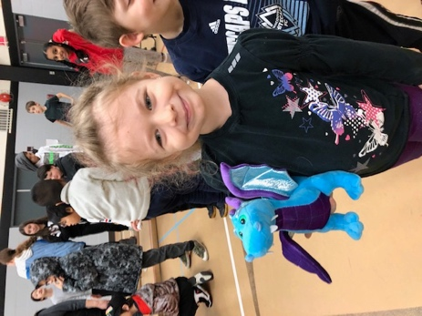

School Virtue- Peacefulness

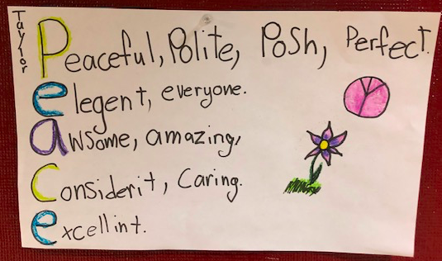

Thank you Ms. Friesen’s class for decorating our virtue board with messages matching our monthly virtue.

Looking Ahead
Scholastic Book Fair- December 3-6
Santa Breakfast- Saturday, December 7 (9:00am-10:30am)
Christmas Concert- December 18 (1:00pm)
Last Day of Classes/Pancake Breakfast- December 20th
First Day Back from the Break- January 6th

